CAMPUS ASSISTANT CHATBOT

Submitted By

Name: Velroy Deiton Fernandes

Roll No: 2408042

Course: B.C.A(Bachelor in Computer Application)

Email: Velroydfernandes05@gmail.com

Introduction

A chatbot is a software application that interacts with users through text-based conversations. This project involves the development of a Campus Assistant Chatbot using Botpress. The chatbot helps students obtain information related to campus facilities, courses, timings, and office contact details.

Objective

To develop a Campus Assistant Chatbot that provides quick and accurate information about campus-related services and facilities.

Tools Used
- Botpress
- Knowledge Base
- Rich Text Document

Workflow Design

The chatbot starts with a welcome message and uses a knowledge base to answer user queries. If information is not available, it provides an appropriate fallback response.

Screenshot : Workflow Design

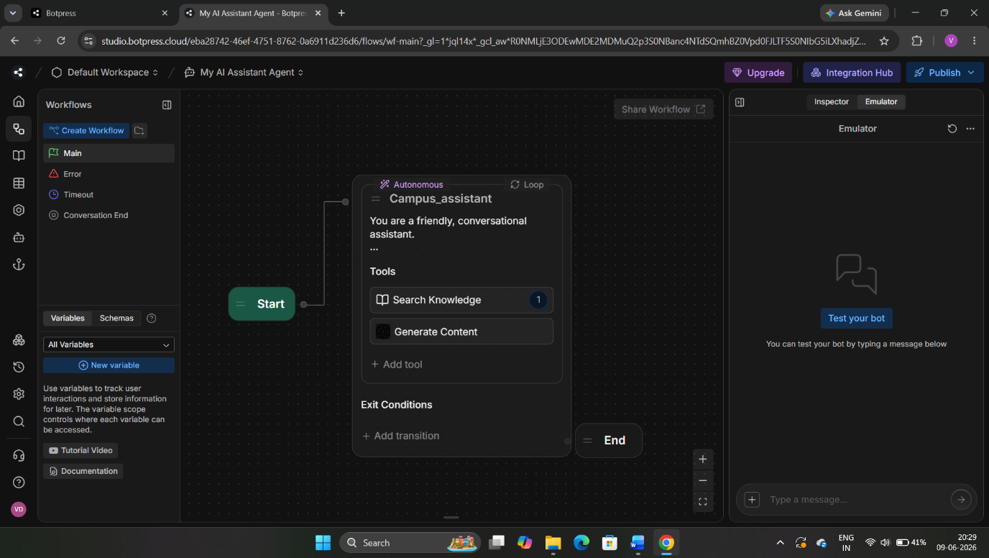

---

Knowledge Base

The chatbot uses a knowledge base containing information about:

- College Timings
- Library Location
- Computer Lab Location
- Courses Available
- Office Contact Information

Screenshot : Knowledge Base

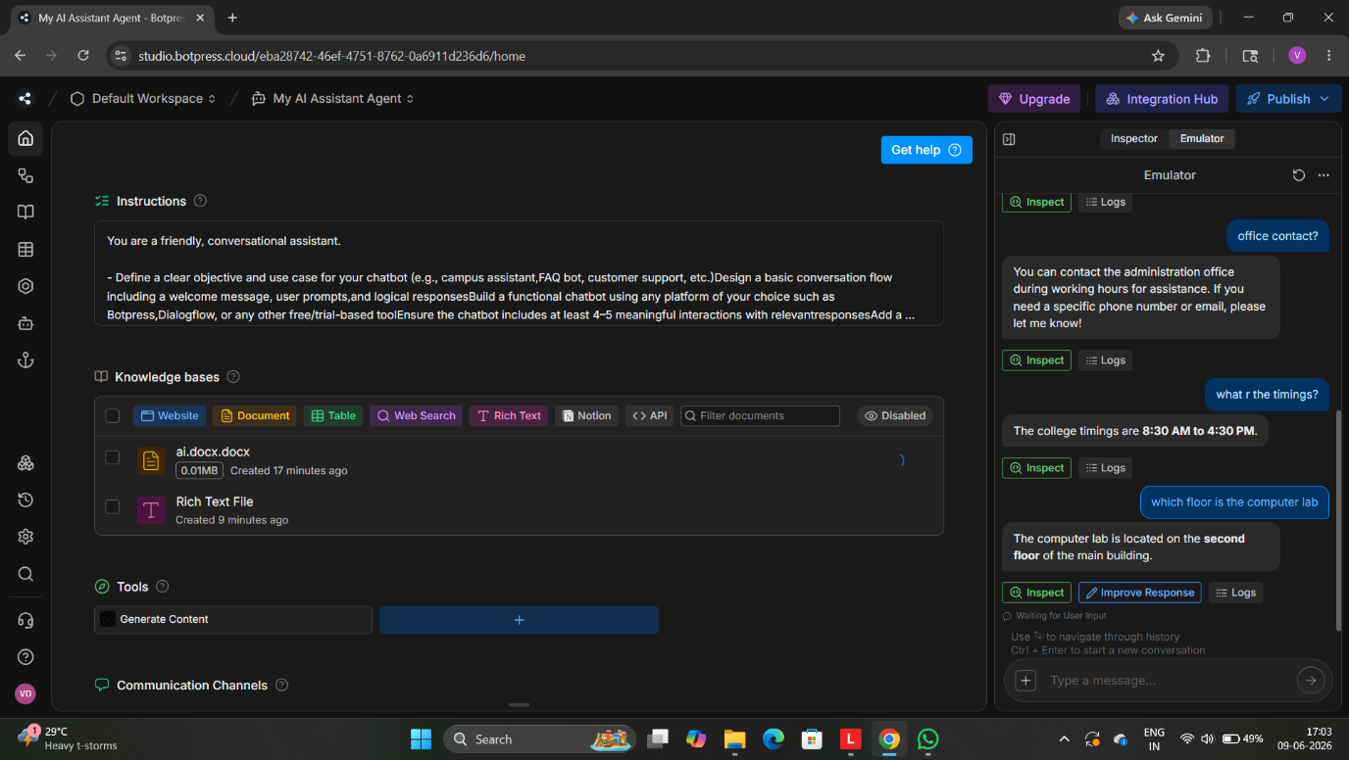

Testing and Results

Test Case 1

User Query: What courses are available?

Bot Response:
B.Sc Data Science, BCA, B.Com, BA and other programs.
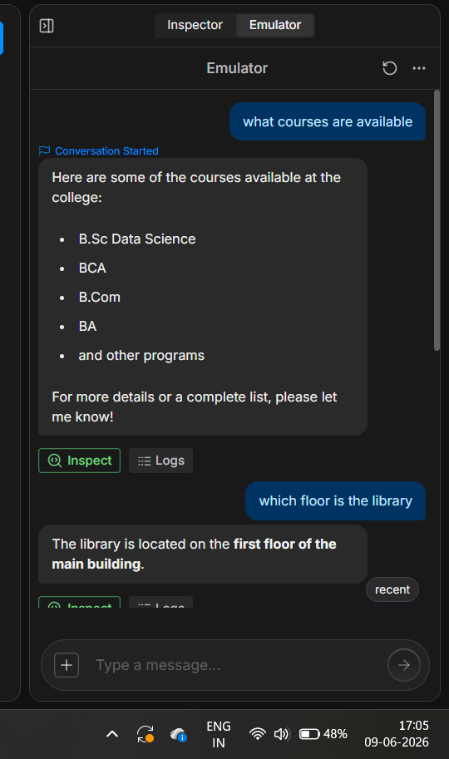

Test Case 2

User Query: Which floor is the library?

Bot Response:
The library is located on the first floor of the main building.

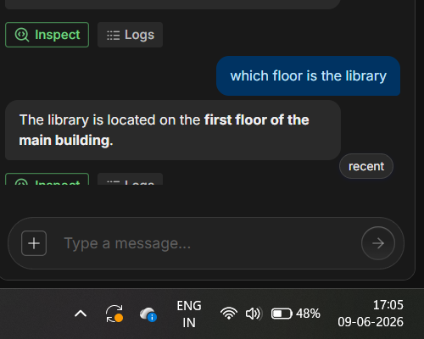

Test Case 3

User Query: Office contact?

Bot Response:
You can contact the administration office during working hours.
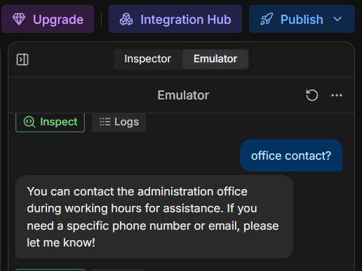

Test Case 4

User Query: What are the timings?

Bot Response:
The college timings are 8:30 AM to 4:30 PM.
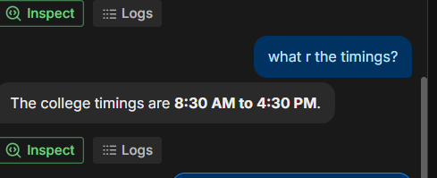

Test Case 5

User Query: Which floor is the computer lab?

Bot Response:
The computer lab is located on the second floor of the main building.

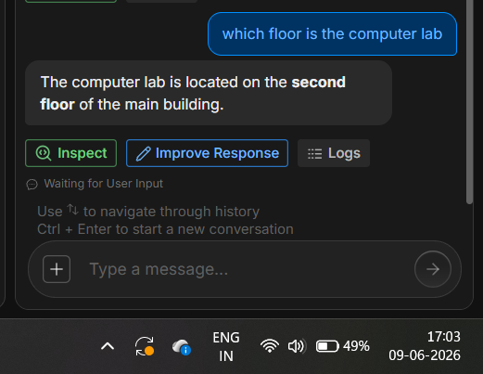

Test Case 6 (Fallback Response)

User Query: What is the campus name?

Bot Response:
I couldn't find information about the campus name in the available resources

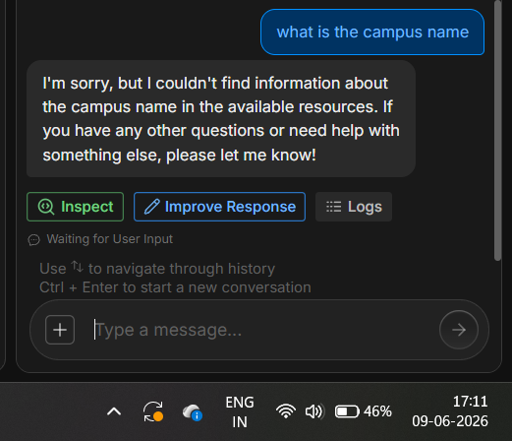
Conclusion

The Campus Assistant Chatbot was successfully developed using Botpress. The chatbot provides useful information regarding courses, library location, computer lab location, office contact details, and college timings. It also handles unknown queries through a fallback response, making it helpful for students seeking campus-related information.

Outcome

The objective of developing a Campus Assistant Chatbot was achieved successfully.

